## horizontal line



Casino

04.02.2019

**─ Cool Funky Studios**

Farkhand, Omer  
Khan, Sharek

Jaspal, Shalini

Web Services Using .NET and C# Programming

PROG37721-1191_68861

# Project Overview

This application is designed as a Casino Simulator, which would offer different Casino games to play, (we are only implementing Black Jack.   
The app would have a registration system, where the player would have their unique account.   
This account will keep track of the player's games played, won, lost, highest/lowest score.   
Will also features a balanced system, so that the money earned by the user is saved with their individual account.  
The game itself will keep track of global records between all players, like a traditional leaderboard.   
A database would keep a record of all this information. The user is required to register to play the game.

# Functional Requirements / Use Cases

1. The Main menu should be able to give the player the option to play, login/register and check how the game is played.
2. Play would start a new instance of a Game, with the associated players, cards, and logic.
3. The Login/Register page will give the option to both login and register on the same page. Login will authenticate the user, validate their information through the database and allow them to play with bidding and score system. Register will ask’s for user credentials and create a new record for them in the database. This information will be used in ‘Login’ for authentication.
4. With the main game, The Dealer will start off Black Jack by shuffling the deck and drawing several cards (dependent on the number of player(s) on table), which are then given to the player(s) and the dealer keeps the other 2. The Player then has the options to get another card, stand or double down.
5. Selecting “Hit Me!” will give the player another card, selecting “Stand” is the option to choose if the player decides the value of the cards, they have is enough, Selecting “Double Down” will Multiply the player’s bet by 2, select another card and stand at that value.
6. The Leaderboard will keep track of all the games played, wins and losses of all the registered players, as well as the players individual records. All through a database call.

# UI Design

# 

Main Menu - This is the first page the user is greeted to. They’ll have the option to play the game which would allow the user to play Blackjack if they are logged in. Selecting register will redirect the user to the Register screen. If not familiar with the game Black Jack, they can learn how to play before starting the game.

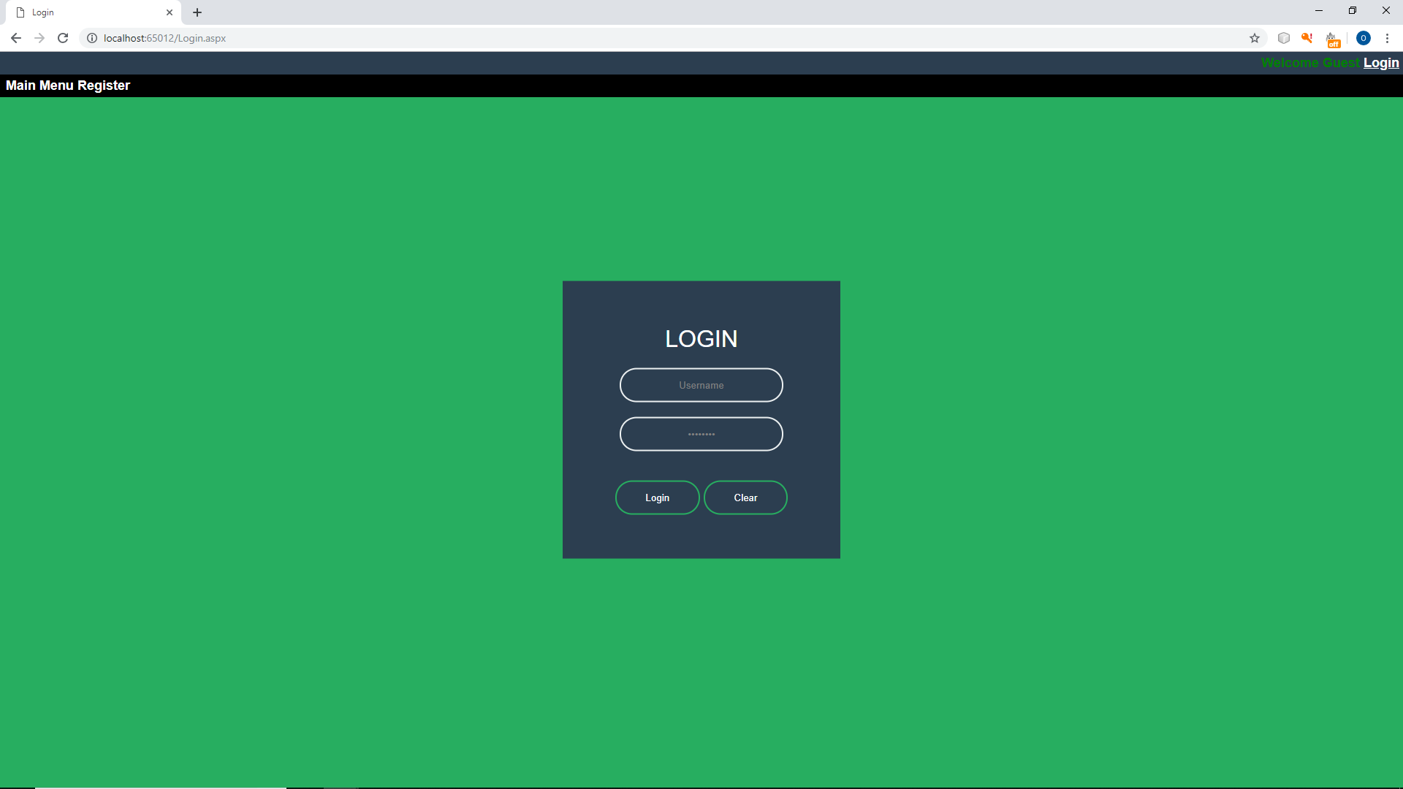

Login Page - This page allows the user to log in to play Blackjack.

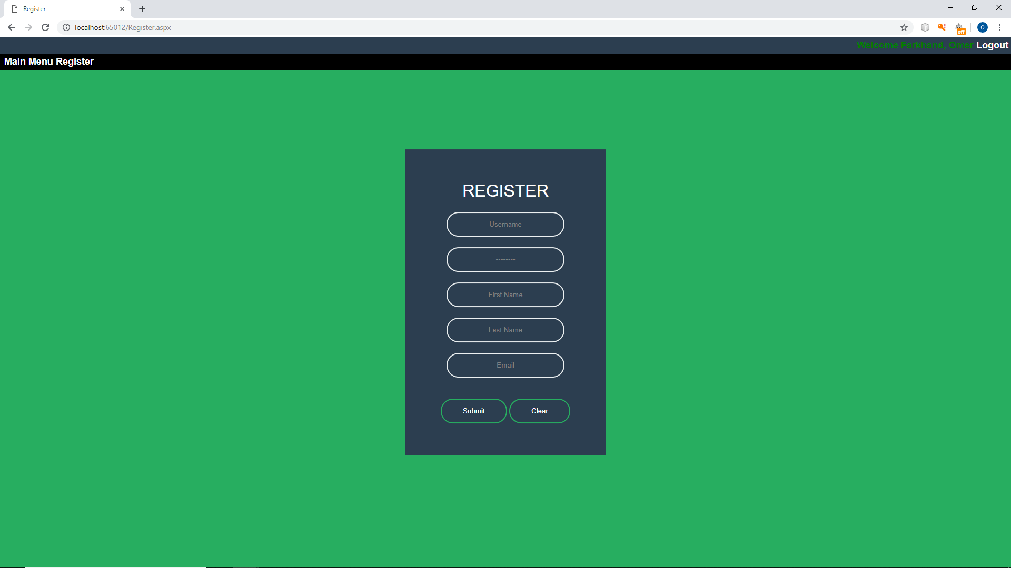

Register Page – This Page allows the user to register onto the database.

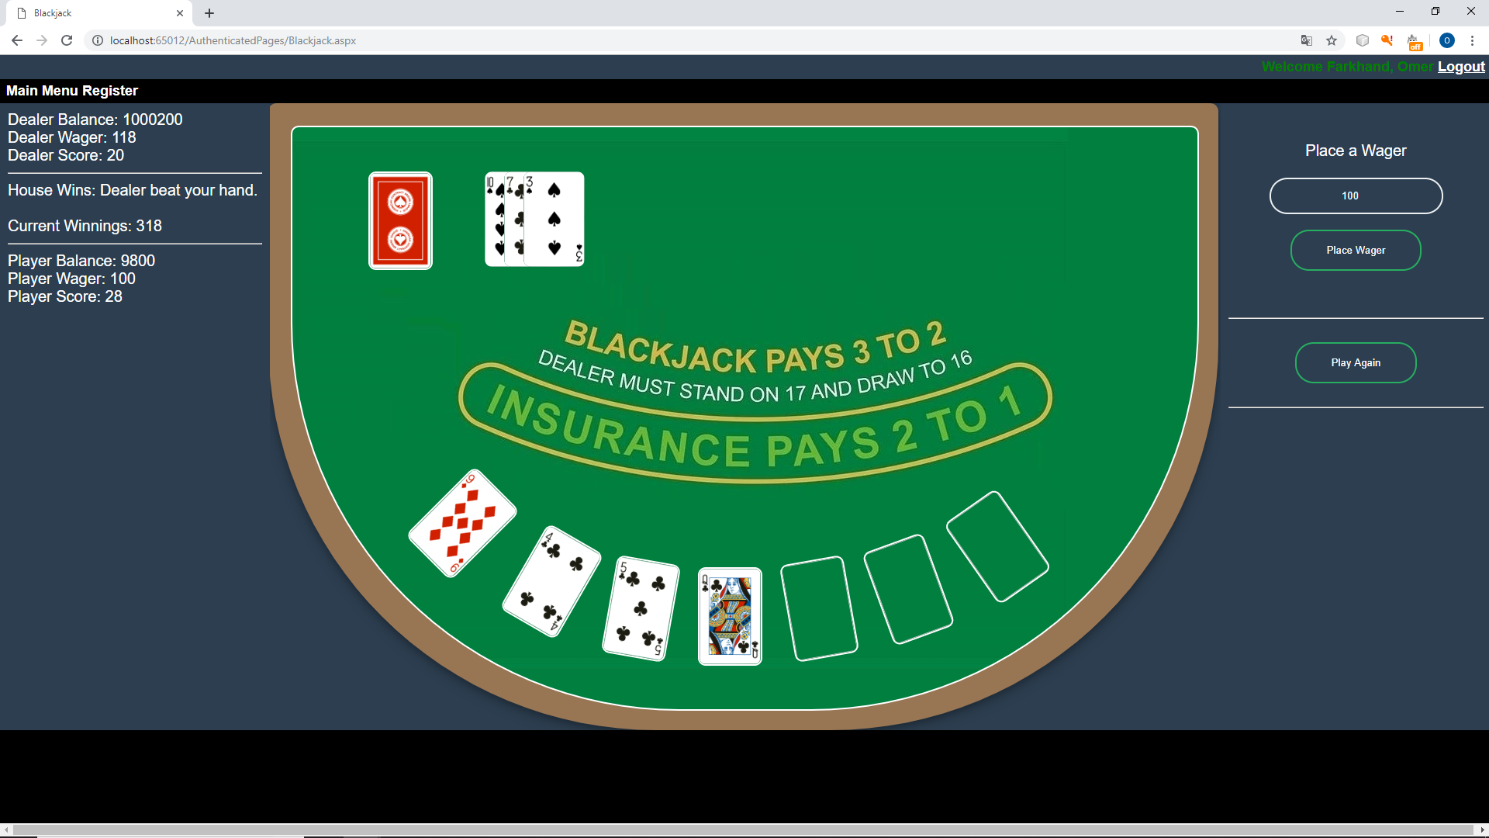

Blackjack Game UI - The main game page. Will run through the game logic and the user would be able to play the game based on the rules set. Would be able to see game decision on one side and numerical output on the other.

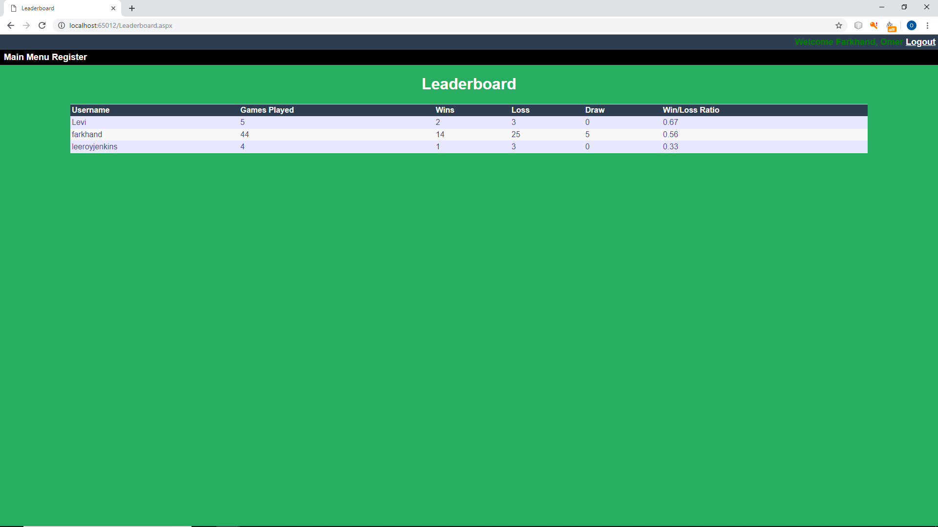

Leaderboard UI - Keeps record of all the players who take a stake in the game. Records of score (for player(s)), game played (either won or lost).

## **Database Design**

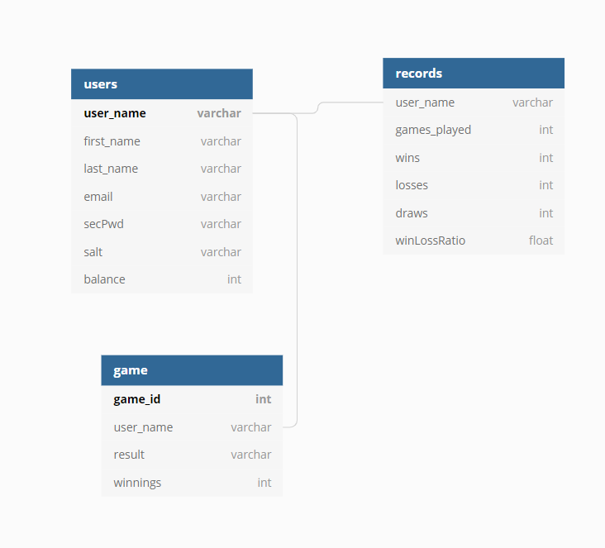

# Work Assignments

## Omer Farkhand

GUI, Business Classes, DAO, Entities

## Sharek Khan

Logic Implementation, Business Class, DAO, Entities

# Project Milestones and Deliverables

Week 5 - Proposal (Develop concept and process on how to develop a Web-Based C# application)

Week 9 - Business classes for all the game Players, Card, Cards, Dealer, etc.

Week 10 - Develop database tables with information from User, Incorporate Business Logic classes with the game UI through events.

Week 11- Develop furthermore on design. Establish a connection with the database server.

Week 12 - Start incorporating the entity class relationships.

Week 13 - Finalize the project, work out bugs, polish it up.

Week 14 - Final Submission

# Project Changes

1. The Main Menu is different we use the Master aspx file to add a login and logout link. We added a sitemap to add a link to register and the main menu.

2. Play still does the same thing in the sense that it still starts a new instance of the Game.

3. The Login link sends the user to the login page and once the user logs in and gets sent to the game or main menu depending on the users choice, the option to login will disappear and turn in to a log out once the user is logged in.

4. Our Program has gone through a complete change in terms of looks. Our original concept used dark colours and the UI used default settings for buttons and text fields. We implemented css code to make it more appealing and more user friendly.

5. We made changes to our database like removing userid and using username as the PK instead we incorporate password hashing in the user table, replaced winnings with game score in the game table and we removed record PK from the records table.